**LINUX COMMANDS WITH EXAMPLE**

* touch : Creates an empty files or update the timestamp of an existing file.

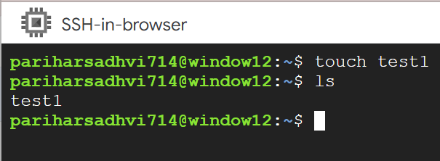

* mkdir : Creates a new directory.

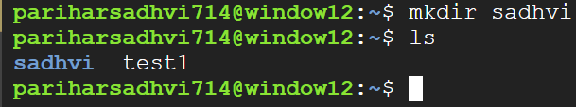

* ls : Lists files and directories in the current directory.

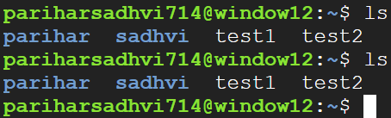

* cd : Changes the current directory.

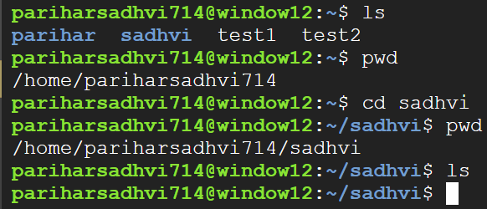

* pwd : It is used to display the current working directory.

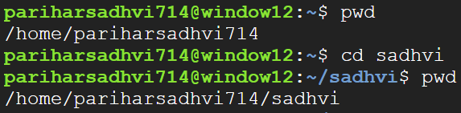

* cd .. : Moves you to the parent directory(one level up)

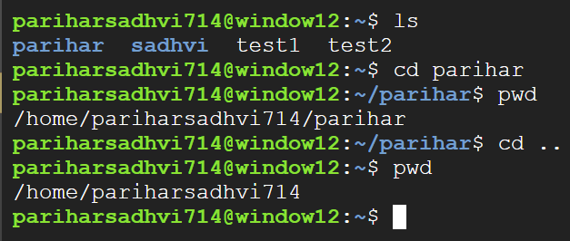

* cat : It is used to displays file content.

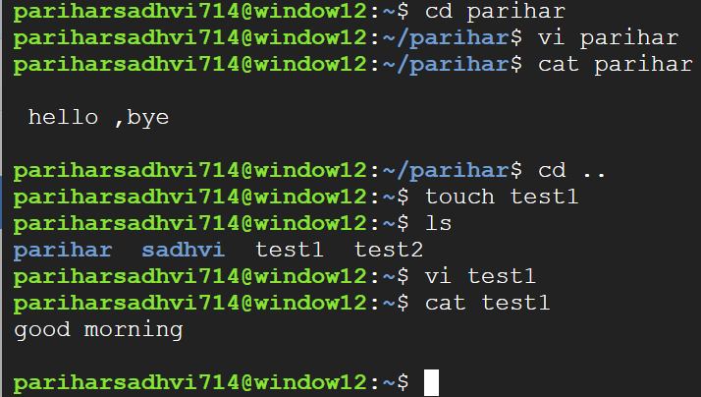

* cat file1 file2 > file3 : It reads the contents of file1 and file2 one after the other and transfer it to the new file it creates i.e file3.

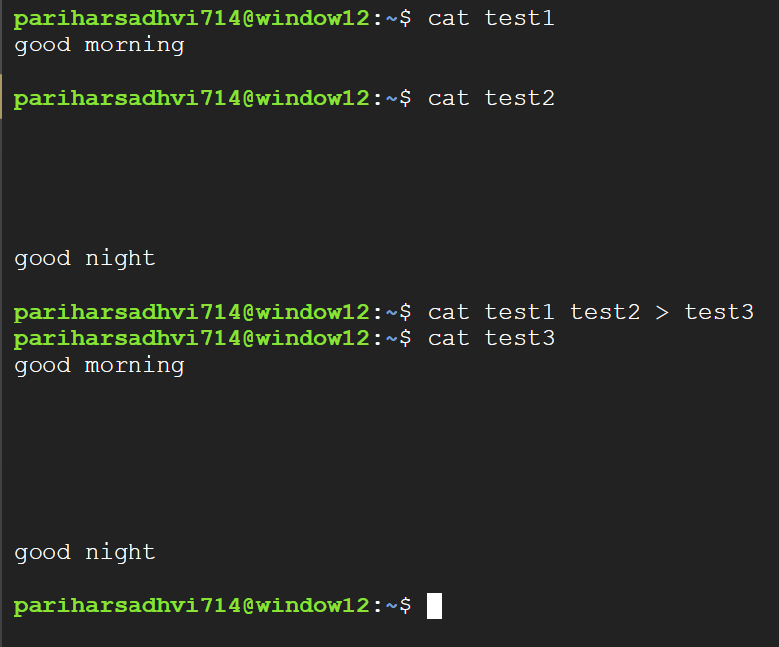

* rm : It is used to remove file.

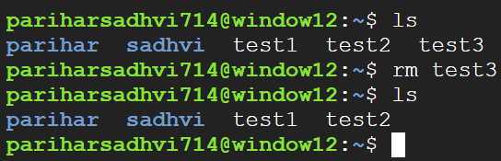

* rmdir : It is used to remove empty directory.

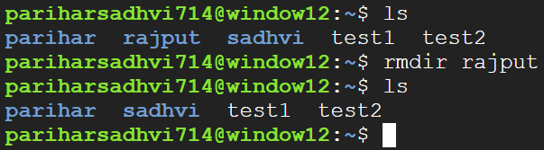

* cp :Copy files or directories.

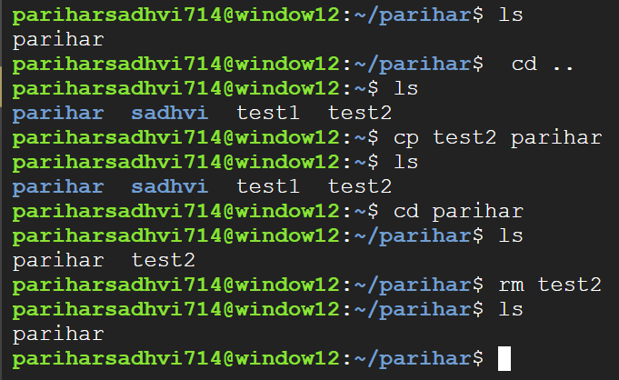

* mv : Move files or directories.

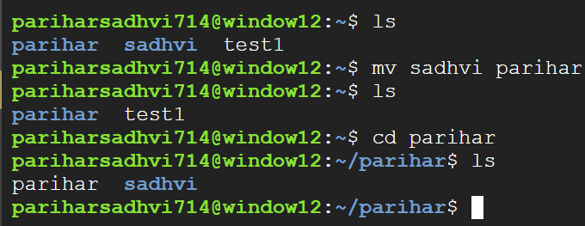

* mv olddir newdir : rename a directory

